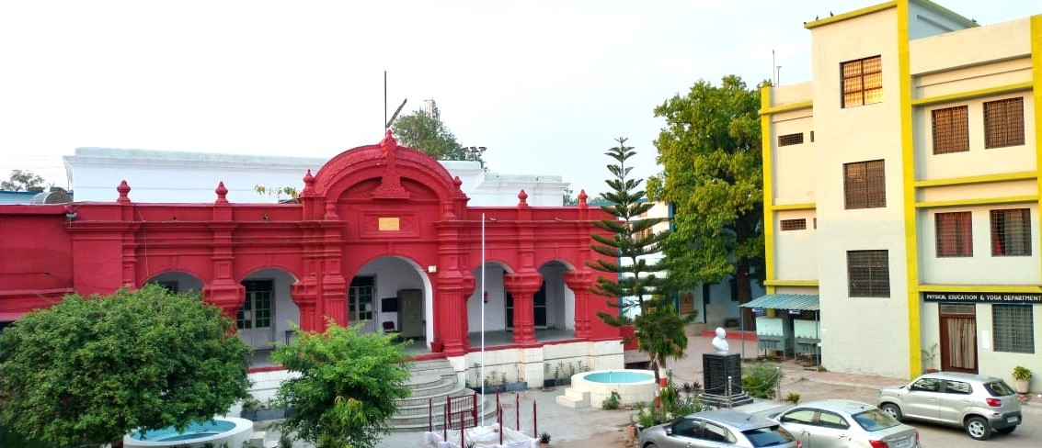

**Criterion - 3**

Research, Innovations and Extension

**3.4.4**

**Number of books and chapters in edited volumes published per teacher during the last five years**

Ref. No. Sagar, Date 07/07/2023

**DECLARATION**

The information, reports, true copies of the supporting documents, numerical data etc. furnished in this file are verified by IQAC and found correct.

Hence this certificate.

Dr. Renu Bala Sharma Dr. Anand Tiwari

Coordinator, IQAC Principal

Ref. No. Sagar, Date / /2024

**Index**

**3.4.4 : Number of books and chapters in edited volumes published per teacher during the last five years**

**Year 2023**

|  |  |  |  |  |  |  |
| --- | --- | --- | --- | --- | --- | --- |
| **S. No.** | **Name of the teacher** | **Title of the book published** | **Title of the chapters published** | **Year of publication** | **ISBN number** | **Link** |
|  | Dr. Sunita Singh | Aquaculture | _ | 2023 | 978-81-963658-1-3 | [View Details](BooksChepters/Dr.%20Sunita%20Singh%20Book%202023%20s1.pdf) |
|  | Dr. Anjana Nema | Poshan evm Naidanik Aahar (Hindi) Vocational Course II year New Education Policy | _ | 2023 | 978-93-95802-89-5 | [View Details](BooksChepters/Dr.%20Anjan%20Nema%20Book%202023%20s2.pdf) |
|  | Dr. Anjana Nema | Nutrition and Health (New Education Policy) | _ | 2023 | 978-81-948713-2-3 | [View Details](BooksChepters/Dr.%20Anjana%20Nema%20Book%202023%20s3.pdf) |
|  | Dr. Aparna Chachondiya | _ | Bhartiya Kala evam Sanskriti main Guru Shishy Parampara | Feb, 2023 | 978-81-956774-3-6 | [View Details](BooksChepters/Dr.%20Aparna%20Chachondiya%20Book%20Chapter%202023%20s4.pdf) |

**Year 2022**

|  |  |  |  |  |  |  |
| --- | --- | --- | --- | --- | --- | --- |
| **S. No.** | **Name of the teacher** | **Title of the book published** | **Title of the chapters published** | **Year of publication** | **ISBN number** | **Link** |
|  | Dr. Poonam Kohli | Novel Bioactive Molecules | _ | August 2022 | 978-93-94894-48-8 | [View Details](BooksChepters/Dr.%20Poonam%20Kohali%20Book%202022%20s1%20&%20s12.pdf) |
|  | Dr. Deepa Khatik | A Text Book of Physics for Engineers | _ | 2022 | 978-93-95331-67-8 | [View Details](BooksChepters/Deepa%20Khatik%20Book%202022%20s2.pdf) |
|  | Dr. Deepa Khatik | Biophysics | _ | 2022 | 978-93-95331-99-9 | [View Details](BooksChepters/Deepa%20Khatik%20Book1%202022%20s3.pdf) |
|  | Dr. R.S. Verma | Nano Science | _ | 2022 | 978-93-95331-59-8 | [View Details](BooksChepters/Dr.%20R.S.%20Verma%20Book%202022%20s5.pdf) |
|  | Dr. R.S. Verma | Operation Amplifier | _ | 2022 | 978-93-95331-59-8 | [View Details](BooksChepters/Dr.%20R.S.Verma%20Book2%202022%20s6.pdf) |
|  | Dr. Anjana Nema | Poshan evm Naidanik Aahar (Hindi) Vocational Course I year New Education Policy | _ | 2022 | 978-93-94032-54-5 | [View Details](BooksChepters/Dr.%20Anjana%20Nema%20Book%202022%20s7.pdf) |
|  | Dr. Nisha Indra Guru | Communicative English (Generic English) | _ | 2022 | 978-939-4032-21-7 | [View Details](BooksChepters/Dr.%20Nisha%20Indra%20Guru%20Book%202022%20s8.pdf) |
|  | Dr. Nisha Indra Guru | Study of Prose | _ | 2022 | 978-93-94032-83-5 | [View Details](BooksChepters/Dr.%20Nisha%20Indra%20Guru%20Book%202022%20s9.pdf) |
|  | Dr. Rajni Dubey | _ | Pandit Jawahar Lal Nehru Ka Manav Suraksha Sambandhi Chintan (21 Sadi Ke Vishesh Sandharbh Me) | 2022 | 978-93-94779-17-4 | [View Details](BooksChepters/Dr.%20Rajni%20Dubey%20Chapter%202022%20s8.pdf) |
|  | Dr. Rajni Dubey | _ | Vaishvikaran Ka Rajya, Samaj, Shiksha, Sanskrati Evam Mulyon Par Prabhav | 2022 | 979-8888-15908-8 | [View Details](BooksChepters/Dr.%20Rajni%20Dubey%20Chapter%202022%20s9.pdf) |
|  | Dr. A.H. Ansari | _ | Xanthium Plants Good Sources of Anticancerous Bioactive Agents | August 2022 | 978-93-94894-48-8 | [View Details](BooksChepters/Dr.%20A.H.Ansari%20Book%20Chapter%202022%20s11.pdf) |
|  | Dr. Poonam Kohli | _ | Raloxifene Hydrochloride as Osteoporosis Treatment | August 2022 | 978-93-94894-48-8 | View Details |
|  | Dr. Gulab Devi | _ | Remote Access Tools, Methods and Technology in ICT | 2022 | 978-93-91542-00-9 | View Details |
|  | Dr. Nisha Indra Guru | _ | What is Communication | 2022 | 978-939-4032-21-7 | [View Details](BooksChepters/Dr.%20Nisha%20Indra%20Guru%20Book%20Chapter%202022%20s15.pdf) |
|  | Dr. Nisha Indra Guru | _ | 1. Early Prose Writers 2. American Prose | 2022 | 978-93-94032-83-5 | [View Details](BooksChepters/Dr.%20Nisha%20Indraguru%20Book%20Chapter%202022%20s16.pdf) |
|  | Dr. Nikki Sadaphal (Bangar) | _ | To Study the Phytochemical and antioxidant Activity of Catharanthus rosrus : A Bioactive Plant | August 2022 | 978-93-94894-48-8 | [View Details](BooksChepters/Dr.%20Nikki%20Sadaphal%20Bangar%20Book%20Chapter%202022%20s16.pdf) |
|  | Dr. Mahendra Kumar Mishra | _ | Studies on AM Fungal Association in selected Medicinal plants of Kukru hills in Betul District, MP, India. | 2022 | 978-93-92239-47-2 | [View Details](BooksChepters/Dr.%20Mahendra%20Kumar%20Mishra%20Book%20Chapter%202022%20s17.pdf) |
|  | Dr. Mahendra Kumar Mishra | _ | Biodiversity of Arbuscular Mycorrhizal fungi Associated with some Medicinal plants of Sagar District of Madhya Pradesh. | 2022 | 978-81-953735-8-1 | View Details |

**Year 2021**

|  |  |  |  |  |  |  |
| --- | --- | --- | --- | --- | --- | --- |
| **S. No.** | **Name of the teacher** | **Title of the book published** | **Title of the chapters published** | **Year of publication** | **ISBN number** | **Link** |
|  | Dr. Sunita Singh | Animal Diversity  (Non Chordate) | _ | 2021 | 978-93-91284-10-7 | [View Details](BooksChepters/Dr.%20Sunita%20Singh%20Book%202021%20s1.pdf) |
|  | Dr. Gulab Devi | Health Literacy Among Rural Women in Madhya Pradesh | _ | 2021 | 978-81-910-764-8-6 | View Details |
|  | Dr. Padma Acharya | Manav Vyavhar Par Tanav Ka Prabhav Evam Prabhandhan | **_** | March 2021 | 978-81-949767-1-4 | View Details |
|  | Dr. Padma Acharya | **_** | Covid-19 Ke Manovaighyanik Prabhav Ka Adhyayan | March 2021 | 978-81-949767-1-4 | View Details |
|  | Dr. Anjana Nema | **_** | Nutrition and Mental Health | 2021 | 978-81-949767-1-4 | View Details |
|  | Dr. Sanjay Khare | **_** | Yuva Tanav - Ek Samajik Samasya ka Adhyayan | 2021 | 978-81-949767-1-4 | [View Details](BooksChepters/Dr.%20Sanjay%20Khare%20Book%20Chapter%202021%20s6.pdf) |
|  | Dr. Bhawana Yadav | **_** | Covid-19 : Tanav, Karan evam Samadhan | 2021 | 978-81-949767-1-4 | [View Details](BooksChepters/Dr.%20Bhavana%20Yadav%20Book%20Chapter%202021%20s7.pdf) |
|  | Dr. Rekha Baxy | **_** | Work Place Strees and its Management | 2021 | 978-81-949767-1-4 | [View Details](BooksChepters/Dr.%20Rekha%20Baxy%20Book%20Chapter%202021%20s8.pdf) |

**Year 2020**

|  |  |  |  |  |  |  |
| --- | --- | --- | --- | --- | --- | --- |
| **S. No.** | **Name of the teacher** | **Title of the book published** | **Title of the chapters published** | **Year of publication** | **ISBN number** | **Link** |
|  | Dr. Madan Mohan Chouksey | Cost Accounting | **_** | July 2020 | 978-93-855-89-42-3 | [View Details](BooksChepters/Dr.%20MM%20Chouksey%20Book%202020%20s1.pdf) |
|  | Dr. Madan Mohan Chouksey | Cost Accounting (In Hindi) | **_** | July 2020 | 978-93-855-89-43-0 | [View Details](BooksChepters/Dr.%20MM%20Chouksey%20Book%202020%20s2.pdf) |
|  | Dr. Sunita Singh | Genetics | _ | 2020 | 978-81-945367-7-2 | [View Details](BooksChepters/Dr.%20Sunita%20Singh%20Book%202020%20s3.pdf) |
|  | Dr. Sunita Singh | Vertebrates And Evolution | _ | 2020 | 978-81-945367-5-8 | [View Details](BooksChepters/Dr.%20Sunita%20Singh%20Book%202020%20s4.pdf) |
|  | Dr. Anjana Nema | _ | Changing Pattern of Food Habits in Tribal Population of Betul-Chhindwara Pleteau of M.P. | 2020 | 978-93-81794-44-9 | [View Details](BooksChepters/Dr.%20Anjana%20Nema%20Book%20Chapter%202020%20s5.pdf) |
|  | Dr. Anjana Nema | _ | Balvikas : An Institute for Mental Retorted Children | 2020 | 978-936-81794-45-6 | [View Details](BooksChepters/Dr.%20Anjana%20Nema%20Book%20Chapter%202020%20s6.pdf) |
|  | Dr. Anjana Nema | _ | Fast Food Consumption and Health | 2020 | 978-93-87899-07-0 | View Details |
|  | Dr. Aparna Chachondiya | _ | Vartaman Samay Ke Paripreksha Me Sangeet Shikshan Ka Swaroop (In Hindi) | November 2020 | 978-81-948717-8-1 | [View Details](BooksChepters/Dr.%20Aparna%20Chachodiya%20Book%20Chapter%202020%20s7.pdf) |
|  | Dr. Aparna Chachondiya | **_** | Dharmik Prashtbhumi Par Avsthith Bhartiya Natrayakala | 2020 | 978-93-91267-46-9 | [View Details](BooksChepters/Dr.%20Aparna%20Chachodiya%20Book%20Chapter%202020%20s8.pdf) |

**Voter Awareness Programme**

**Program Name :-** Voter Awareness Programme

**Date of Program :-** 11-07-2018

**Organized by :-** NSS Unit - Govt. Auto. Girls P.G. College of Excellence, Sagar