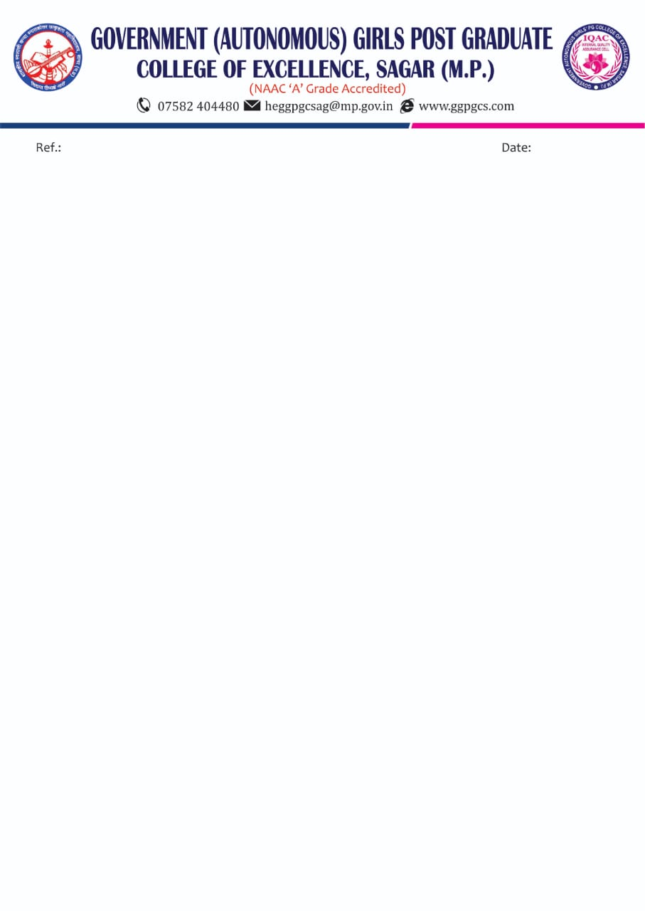

**Gold medal State Level Wrestlling : Nikita Rajpoot (55 kg)**

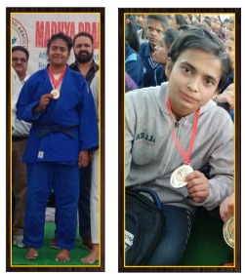

**Gold medal State Level Athletics : Swati Rajpoot**

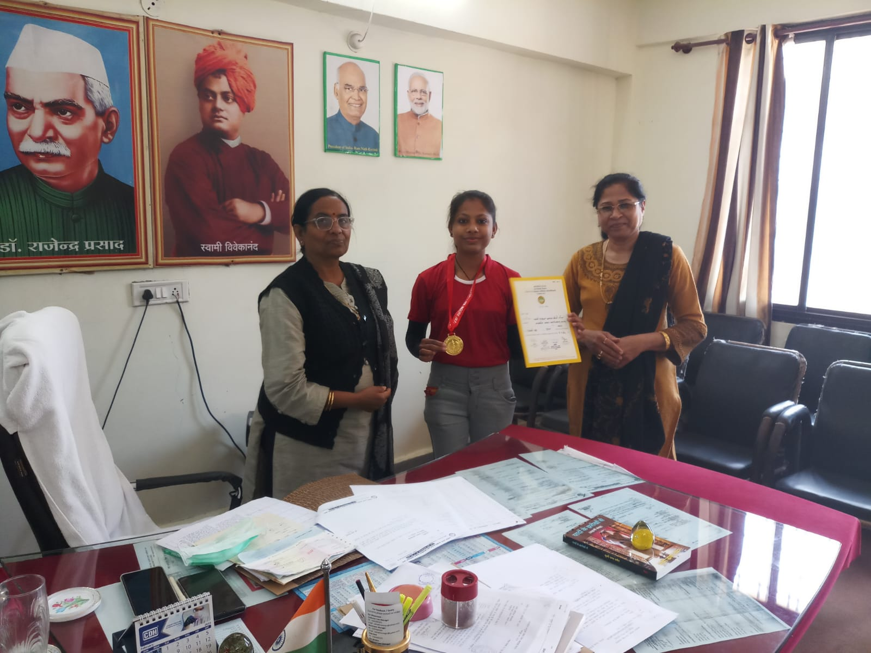

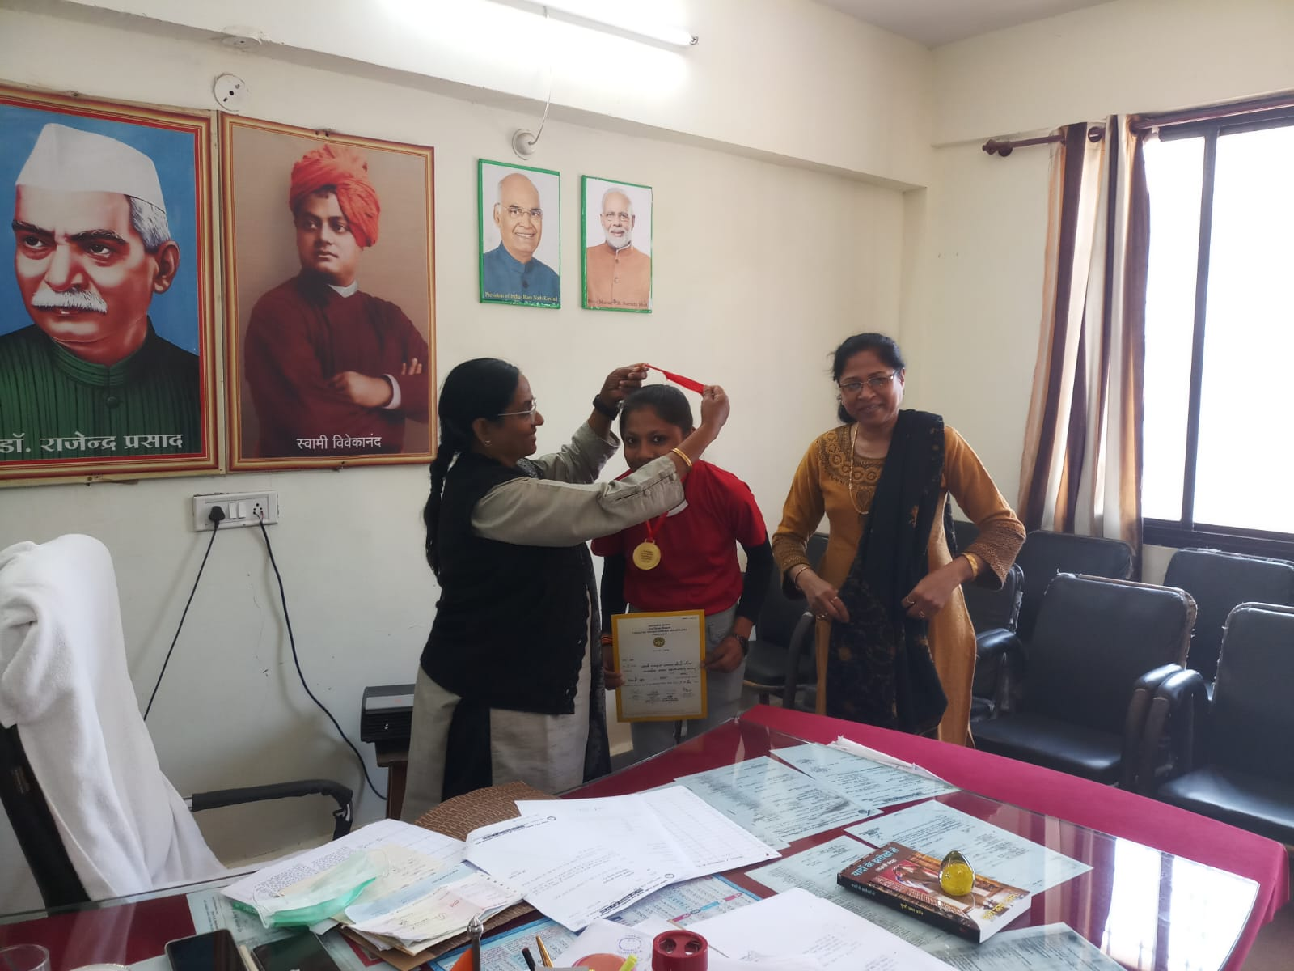

**Gold medal State Level yoga : team**

**1. Samiksha Tiwari**

**2. Shreya Gupta**

**3. Vaishnavi Dangi**

**4. Pooja Rajpoot**

**5. Anjali Patel**

**6. Pratiksha Pandey**

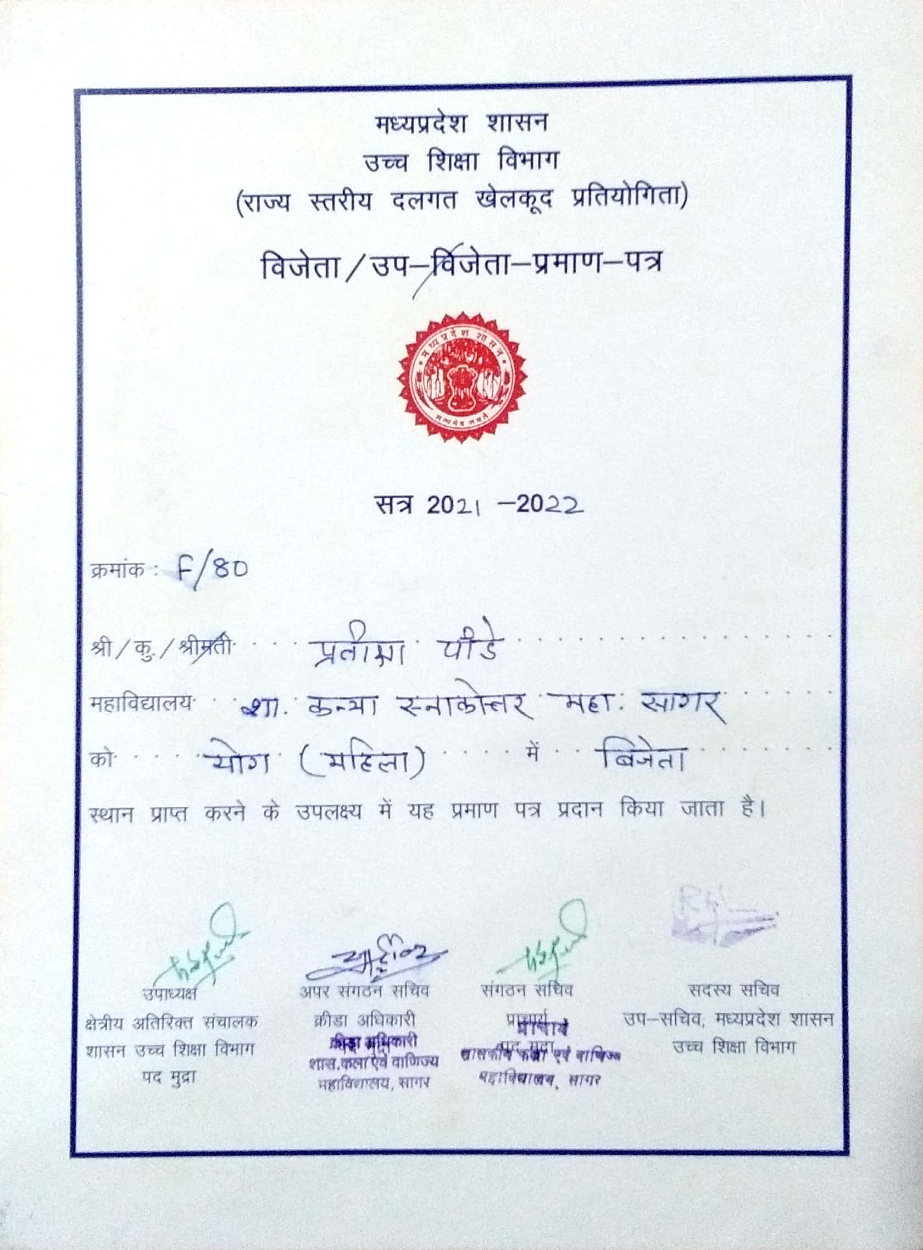

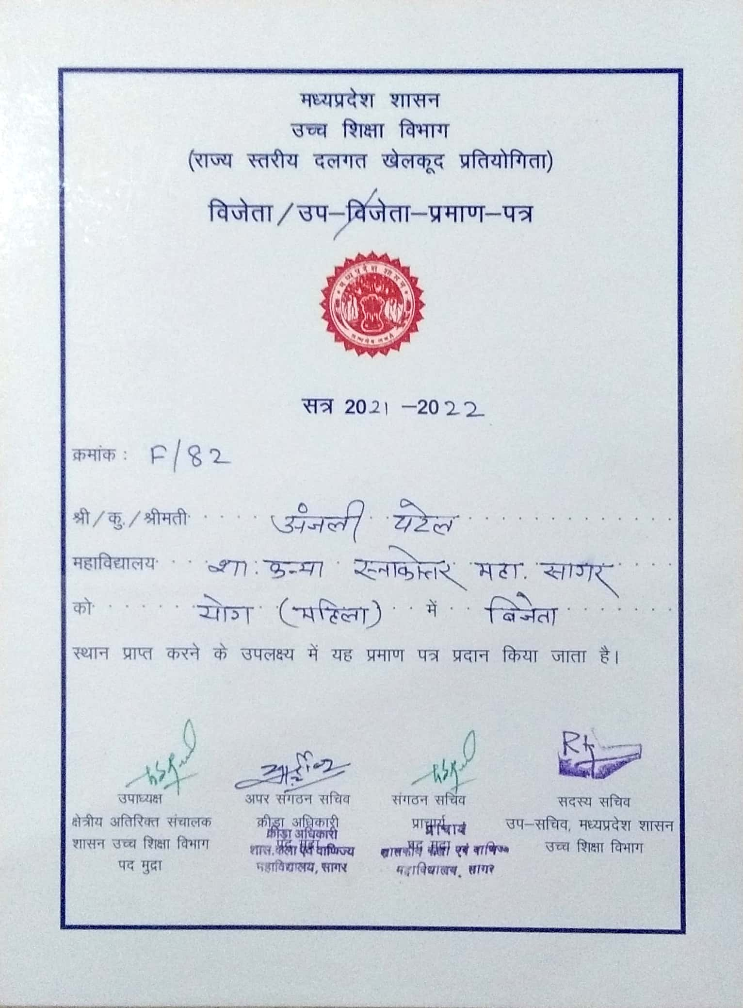

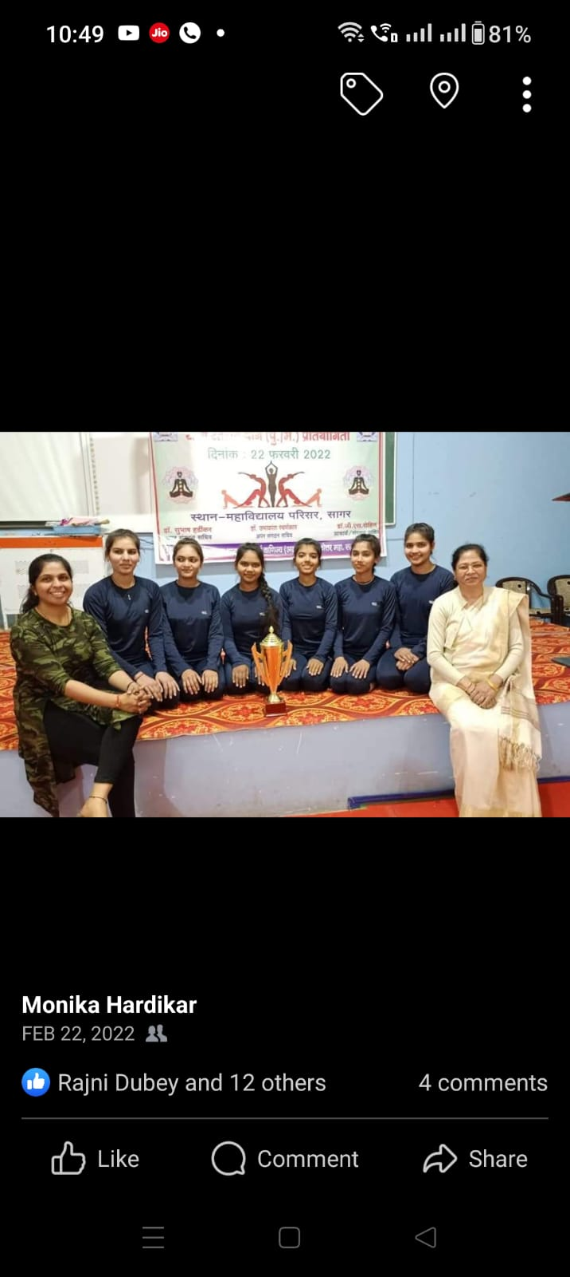

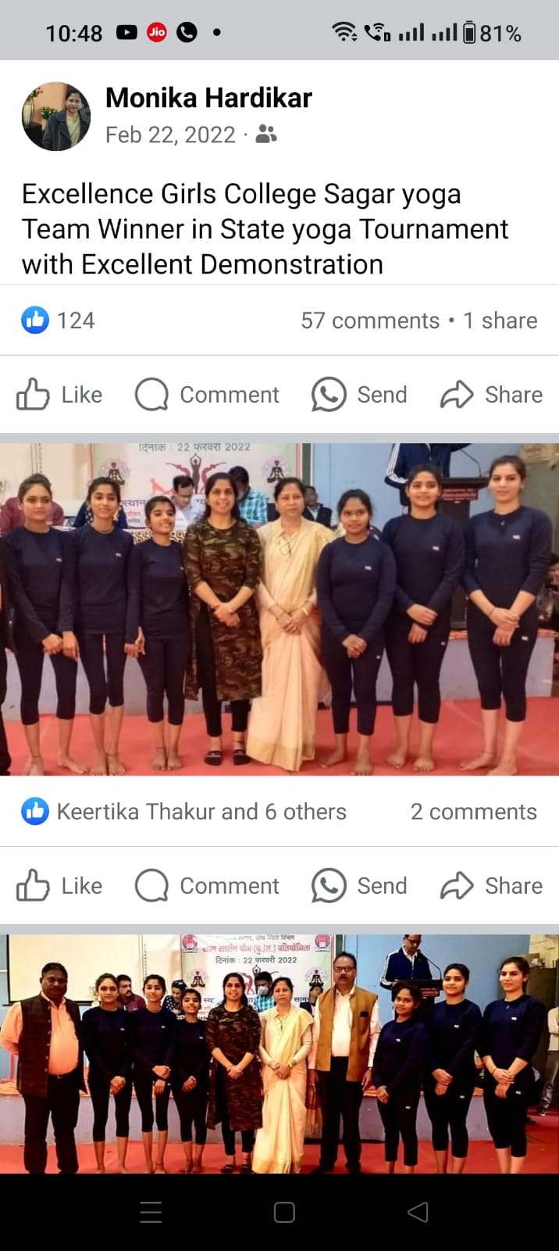

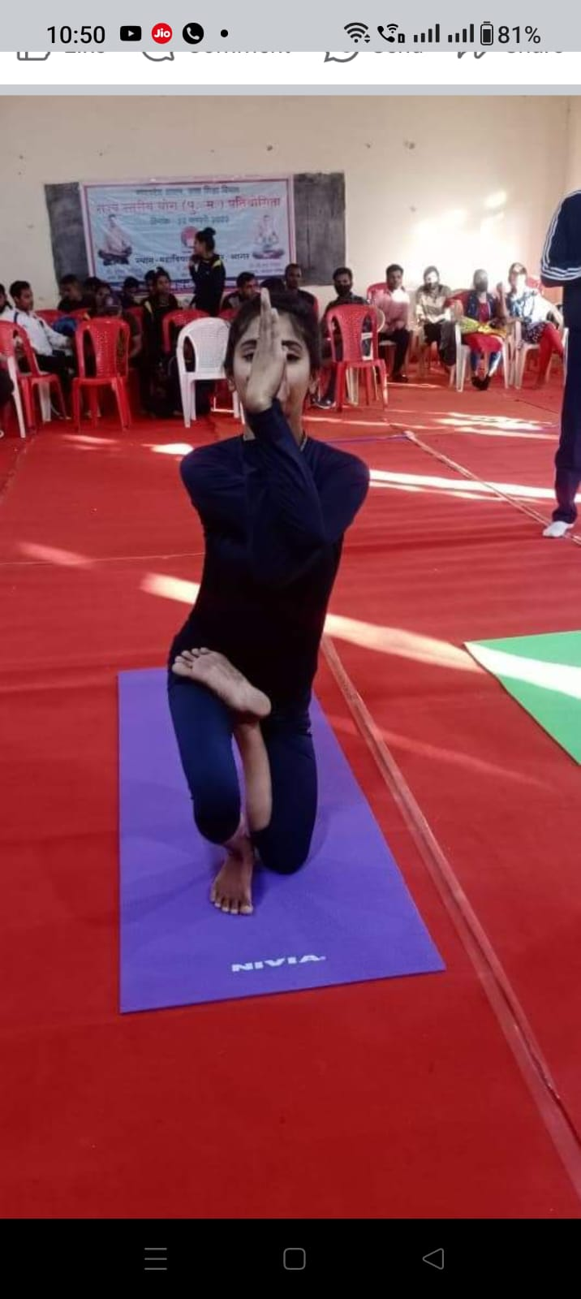

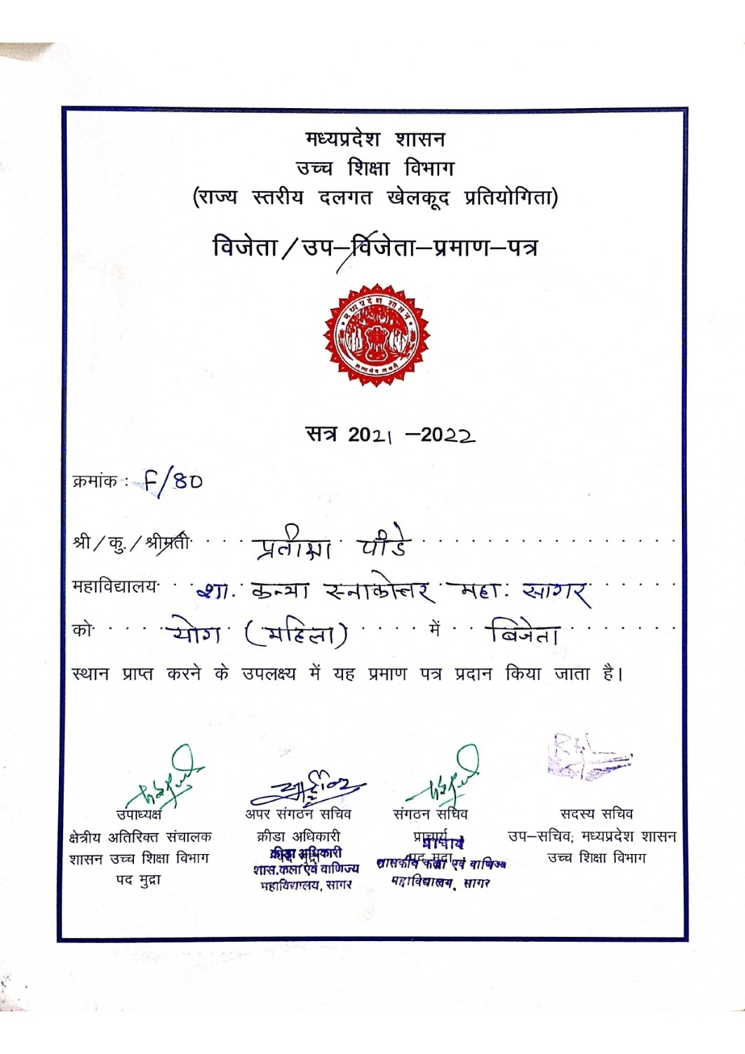

**Inter University : Wrestlling**

**Date : 14.03.2022**

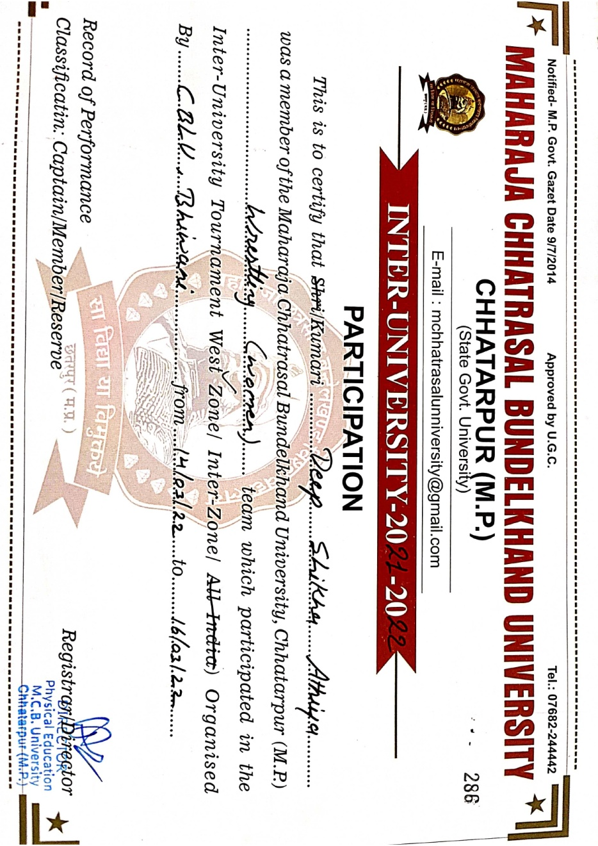**Team : 1. Nikita Rajpoot, 2. Aaradhana Tiwari, 3. Aasha Sen,**

**4. Rajmani Parmar 5. Deepshikha Athiya, 6. Riya Sahu**

**7. Vinita Patel, 8. Deepshikha Dangi**

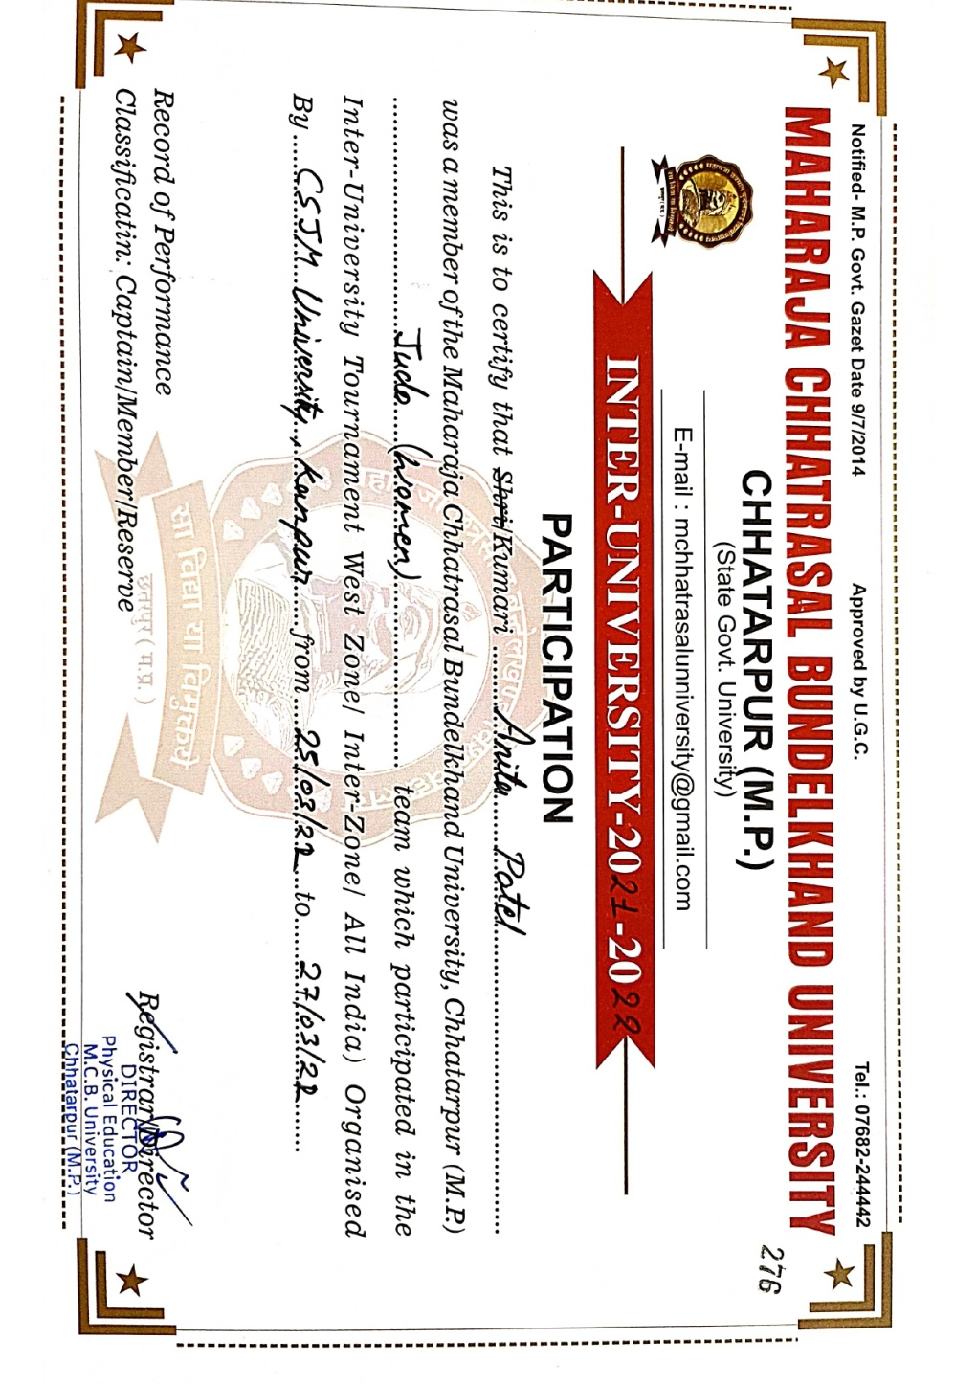**all india Inter University : judo**

**Date : 22.03.2022**

**Team : 1. Radhika Goswami, 2. Aakanksha Yadav, 3. Anita Patel**

**Inter University : Kabbadi**

**Date : 27.12.2021**

**Team : 1. Samiksha Agarwal, 2. Nisha Patel**

**3. Muskan Vishwakarma, 4. Anuja Garg**

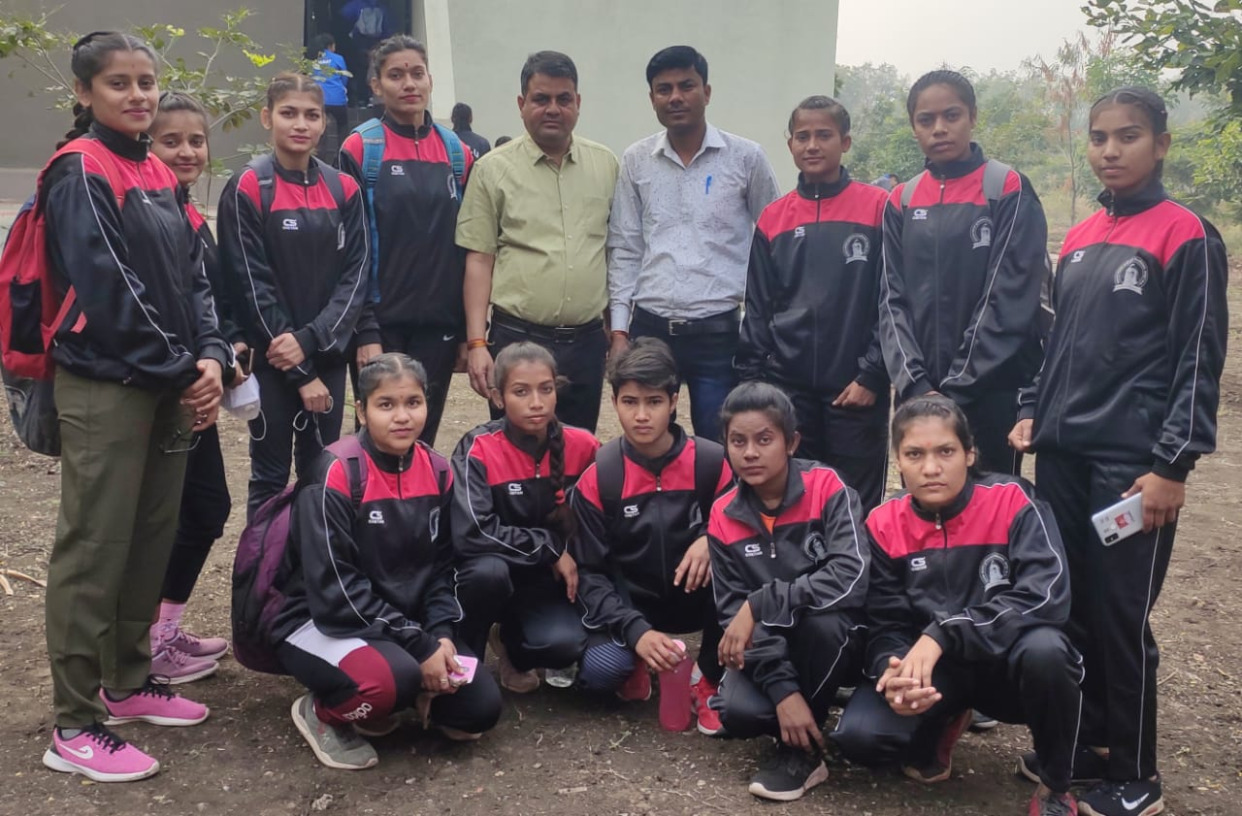

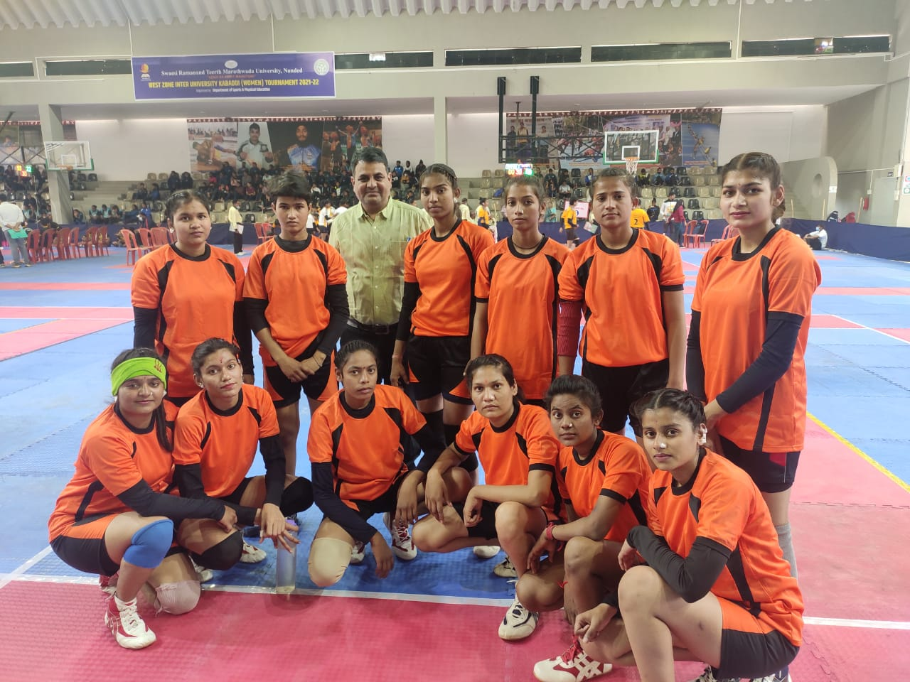

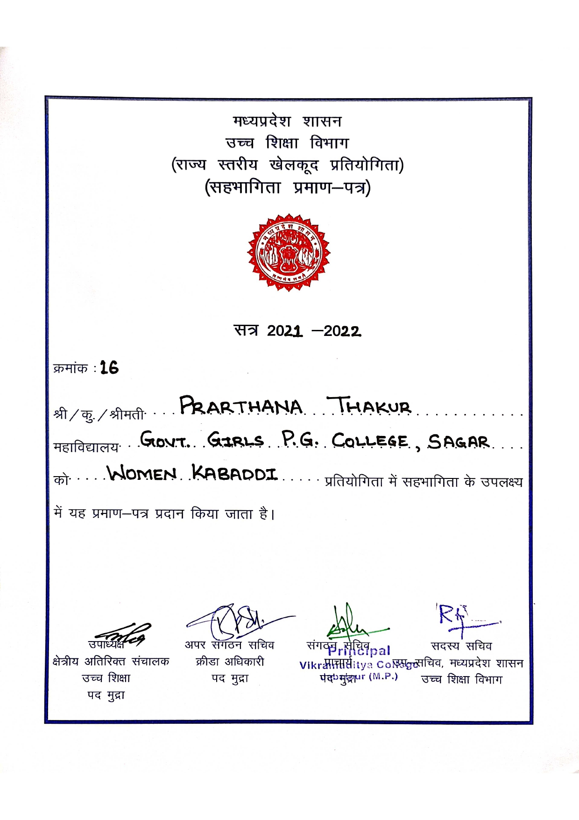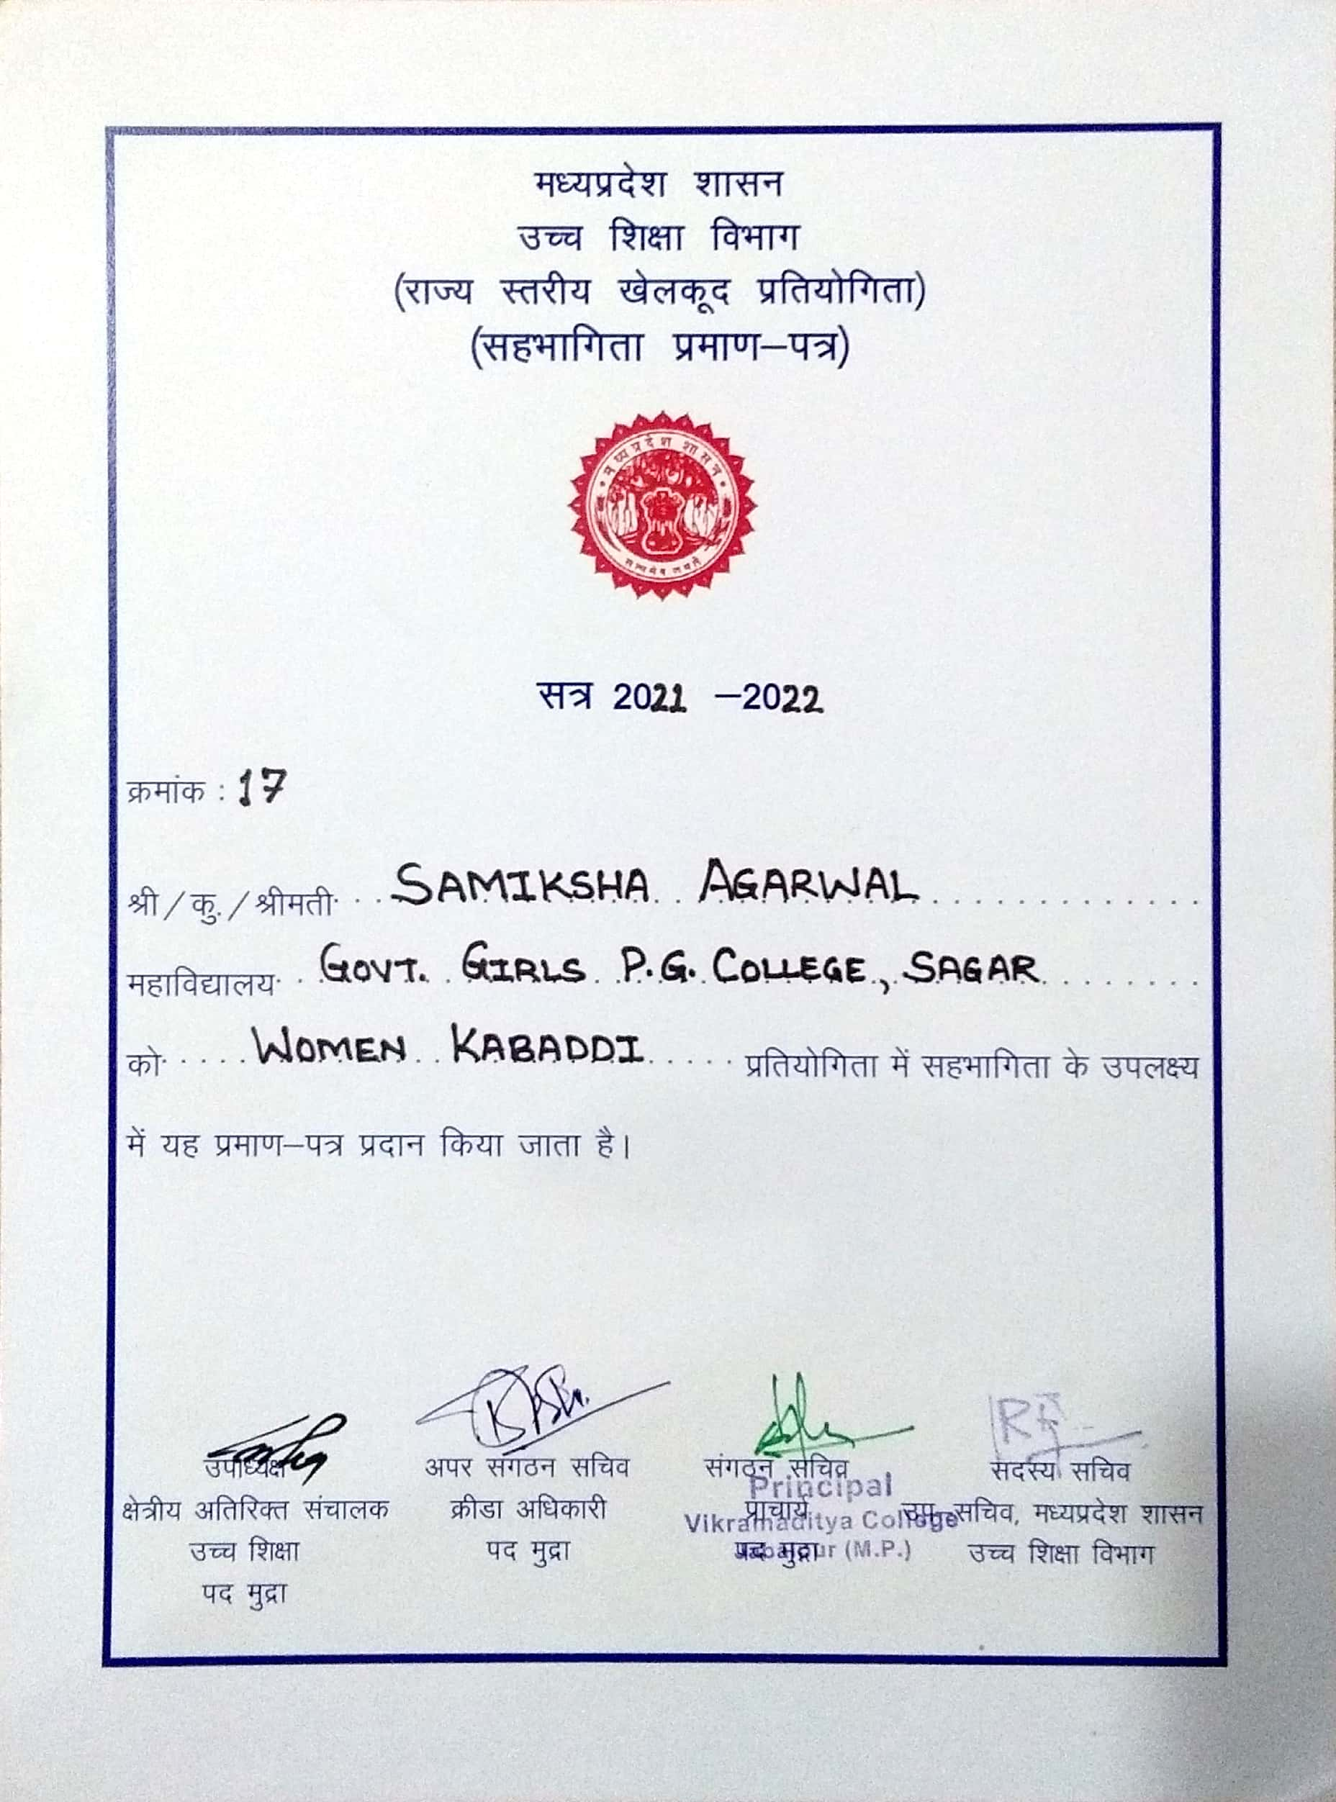

**Inter University : Volleyball**

**Date : 19.12.2021**

**Team : 1. Pallavi Ahirwar, 2. Nandini Sen, 3. Aditi Baxy**

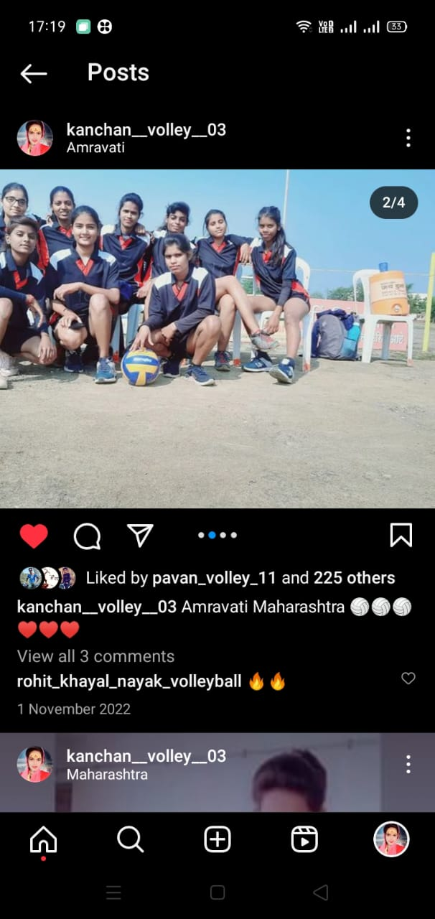

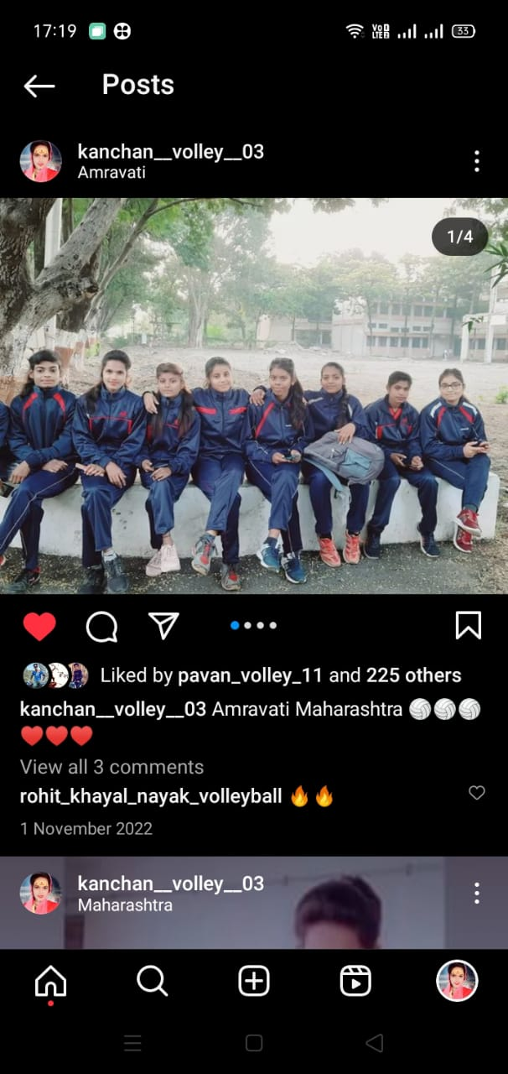

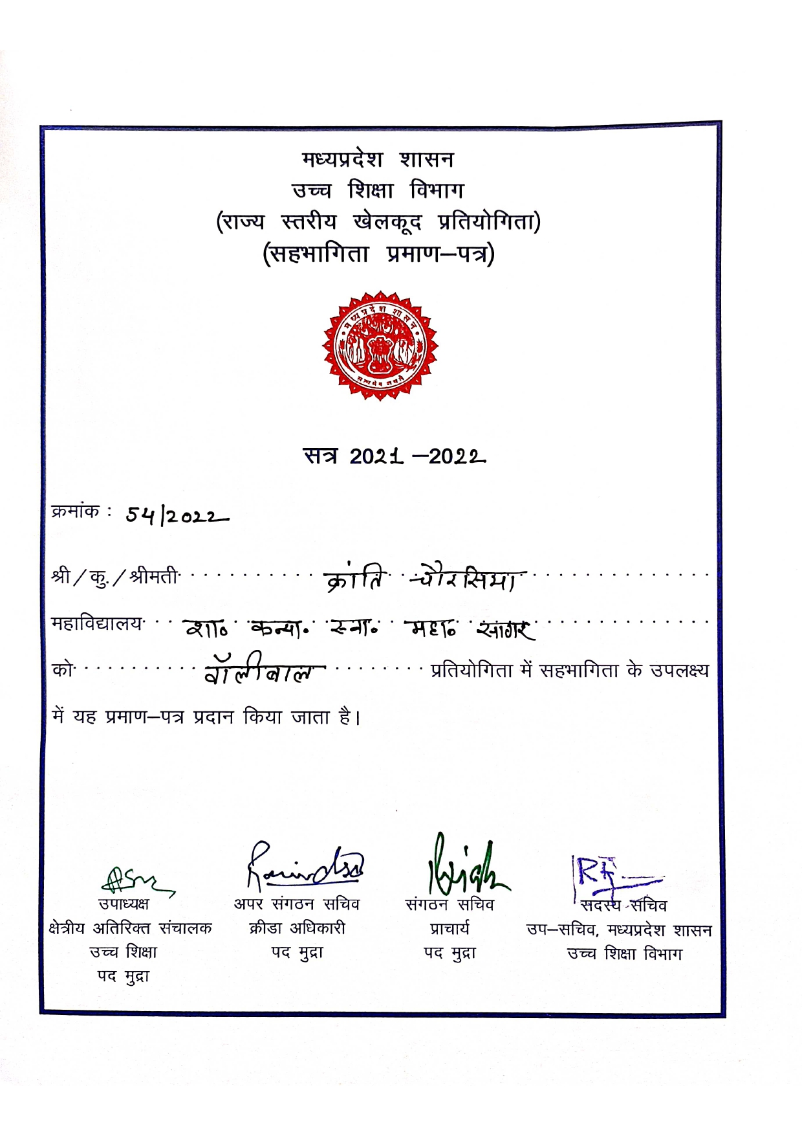

**Inter University : Cricket**

**Date : 21.06.2022**

**Team : 1. Prapti Kurmi, 2. Ritu Mahdele**

**3. Raksha Yadav, 4. Kranti Sour, 5. Kanchan Dangi**

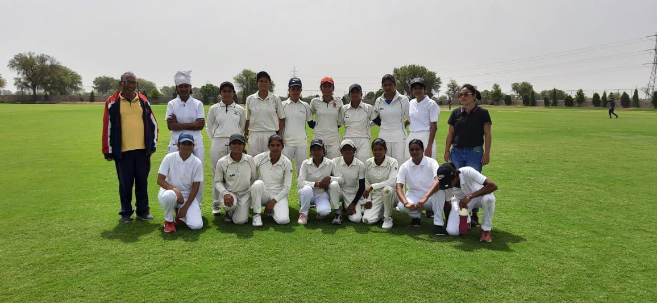

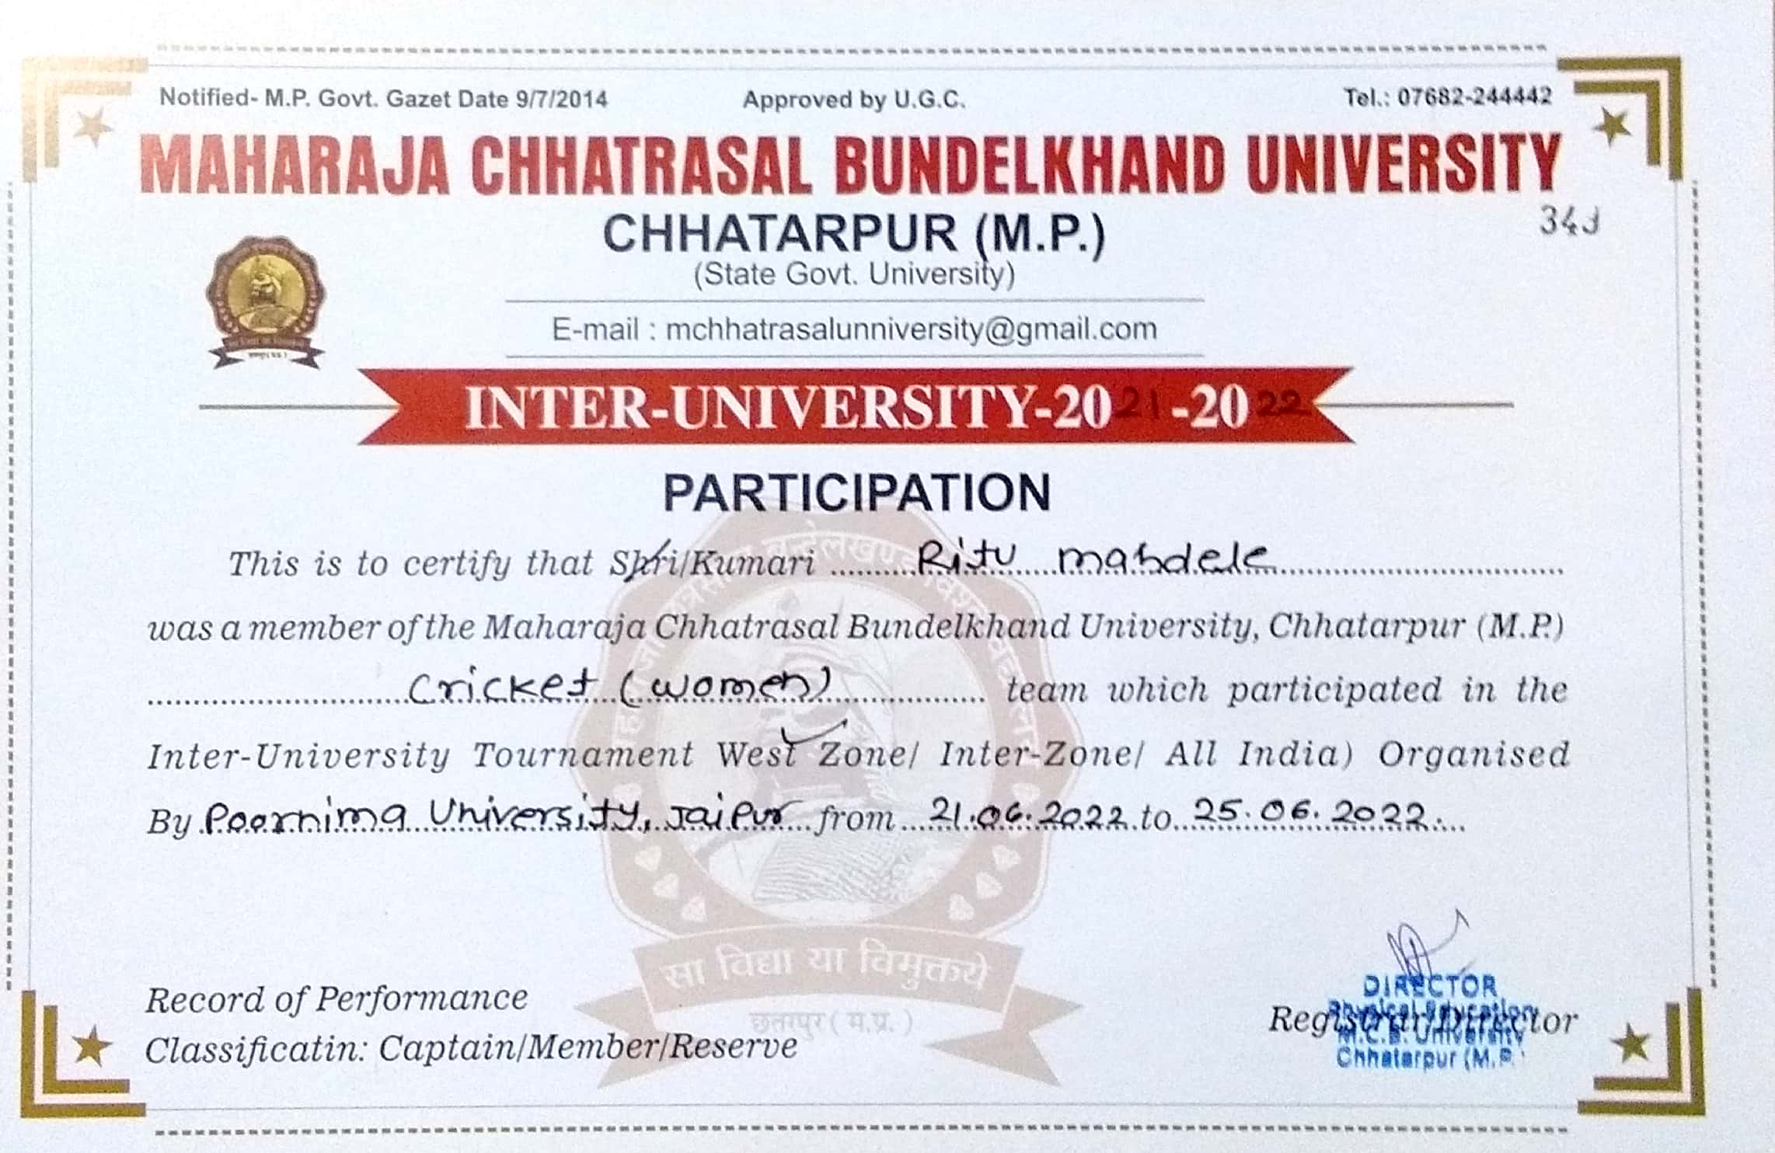

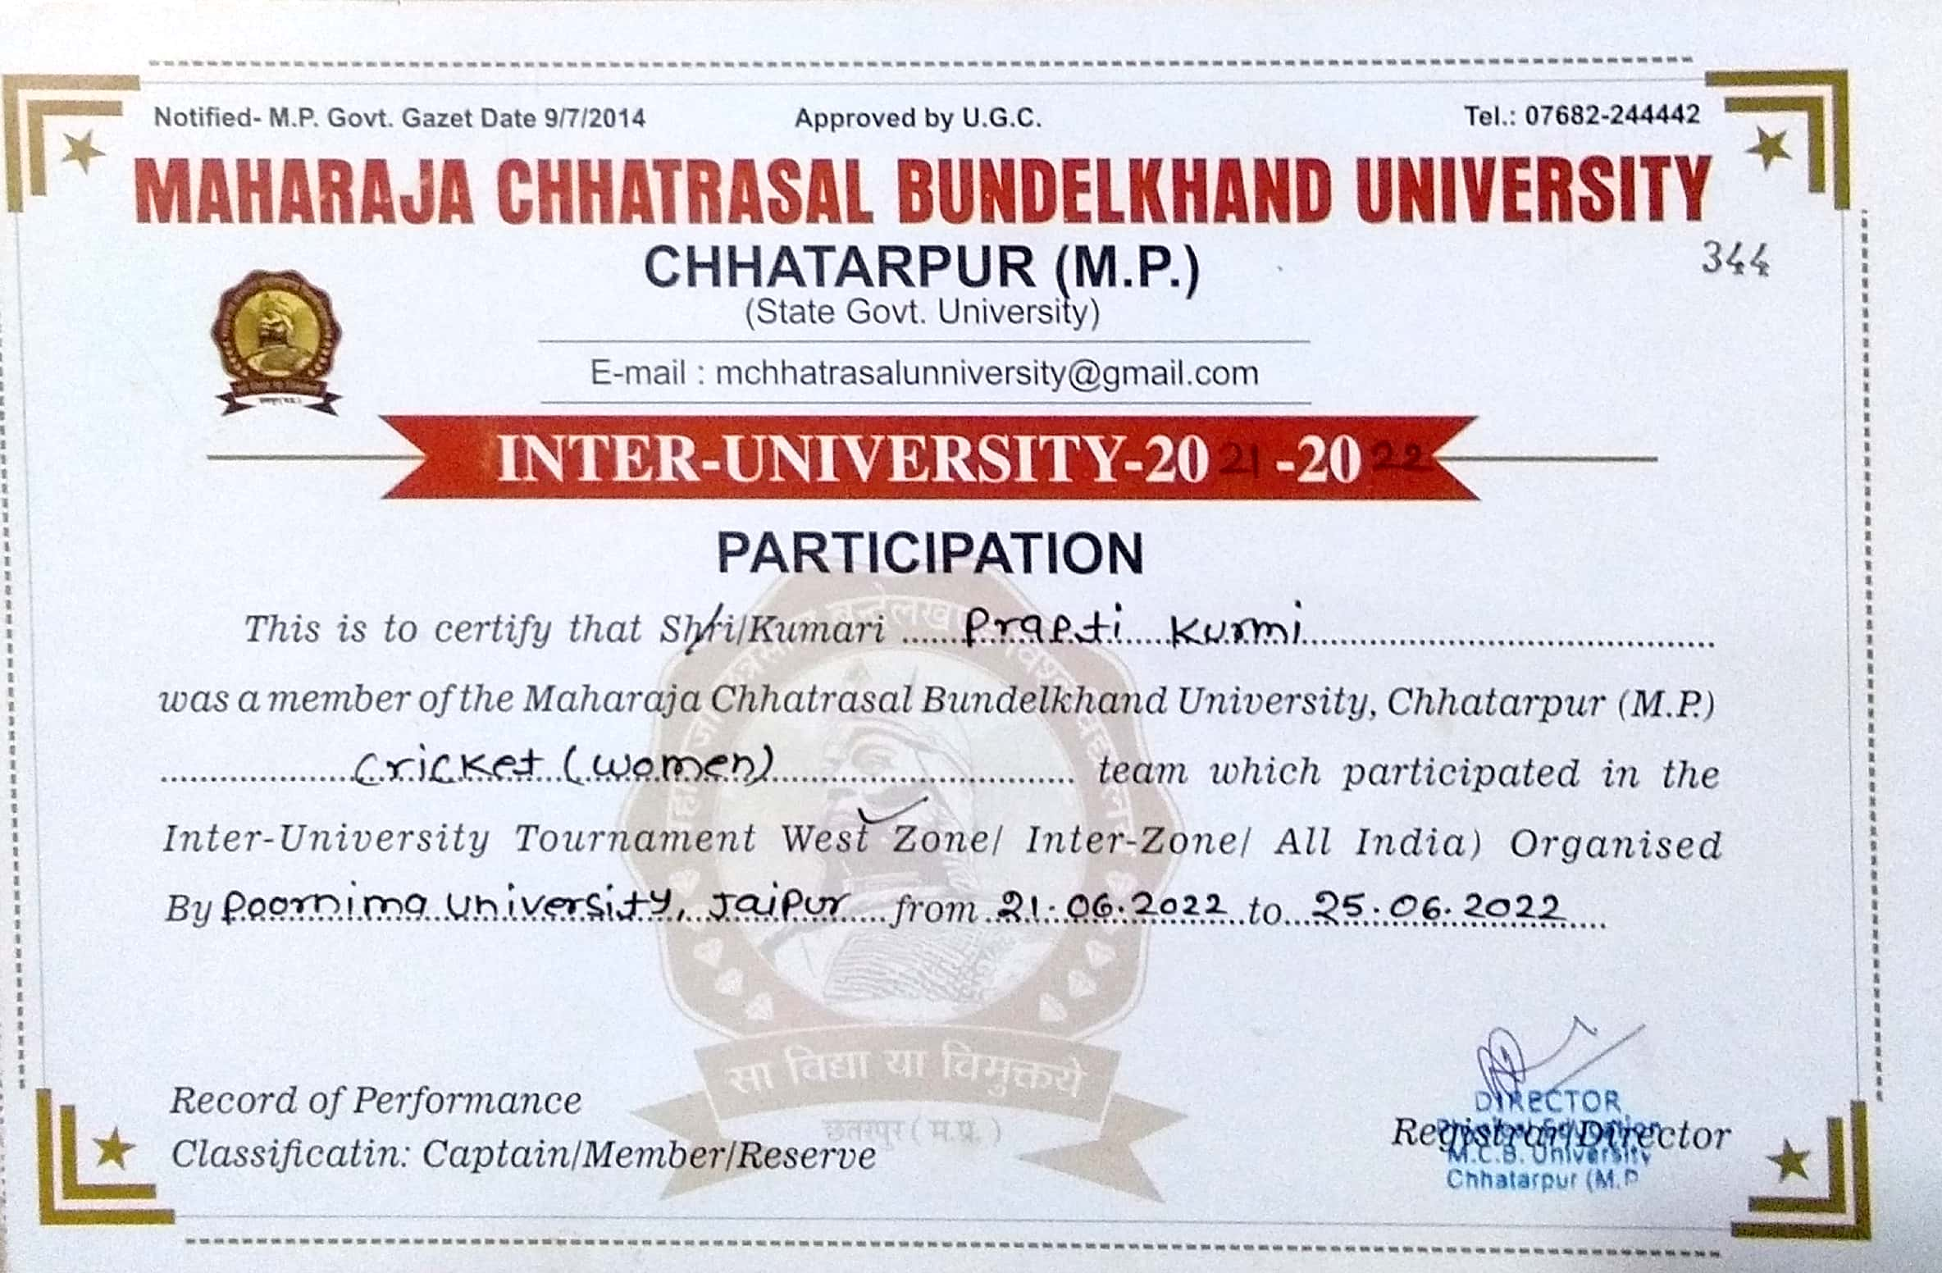

**All India Inter University : Yoga**

**Date : 25.12.2021**

**Team : 1. Shreya Gupta, 2. Samiksha Tiwari, 3. Vaishanavi Dangi**

**4. Pooja Rajpoot, 5. Anjali Patel, 6. Prateeksha Pandey**

